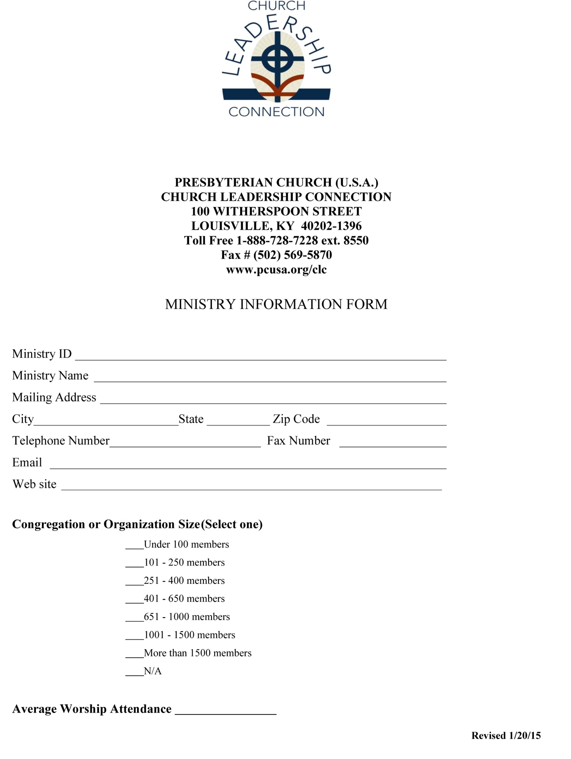

It is best to create a PNC specific email, rather than to use the church’s for confidentiality purposes

Be sure that you have cleaned your rolls, or be able to explain the relationship between congregation size and average worship attendance.

Be sure that your website is up to date and that it has information about your pastor search and other information that a candidate would find interesting/helpful.

This is where you put your church PIN

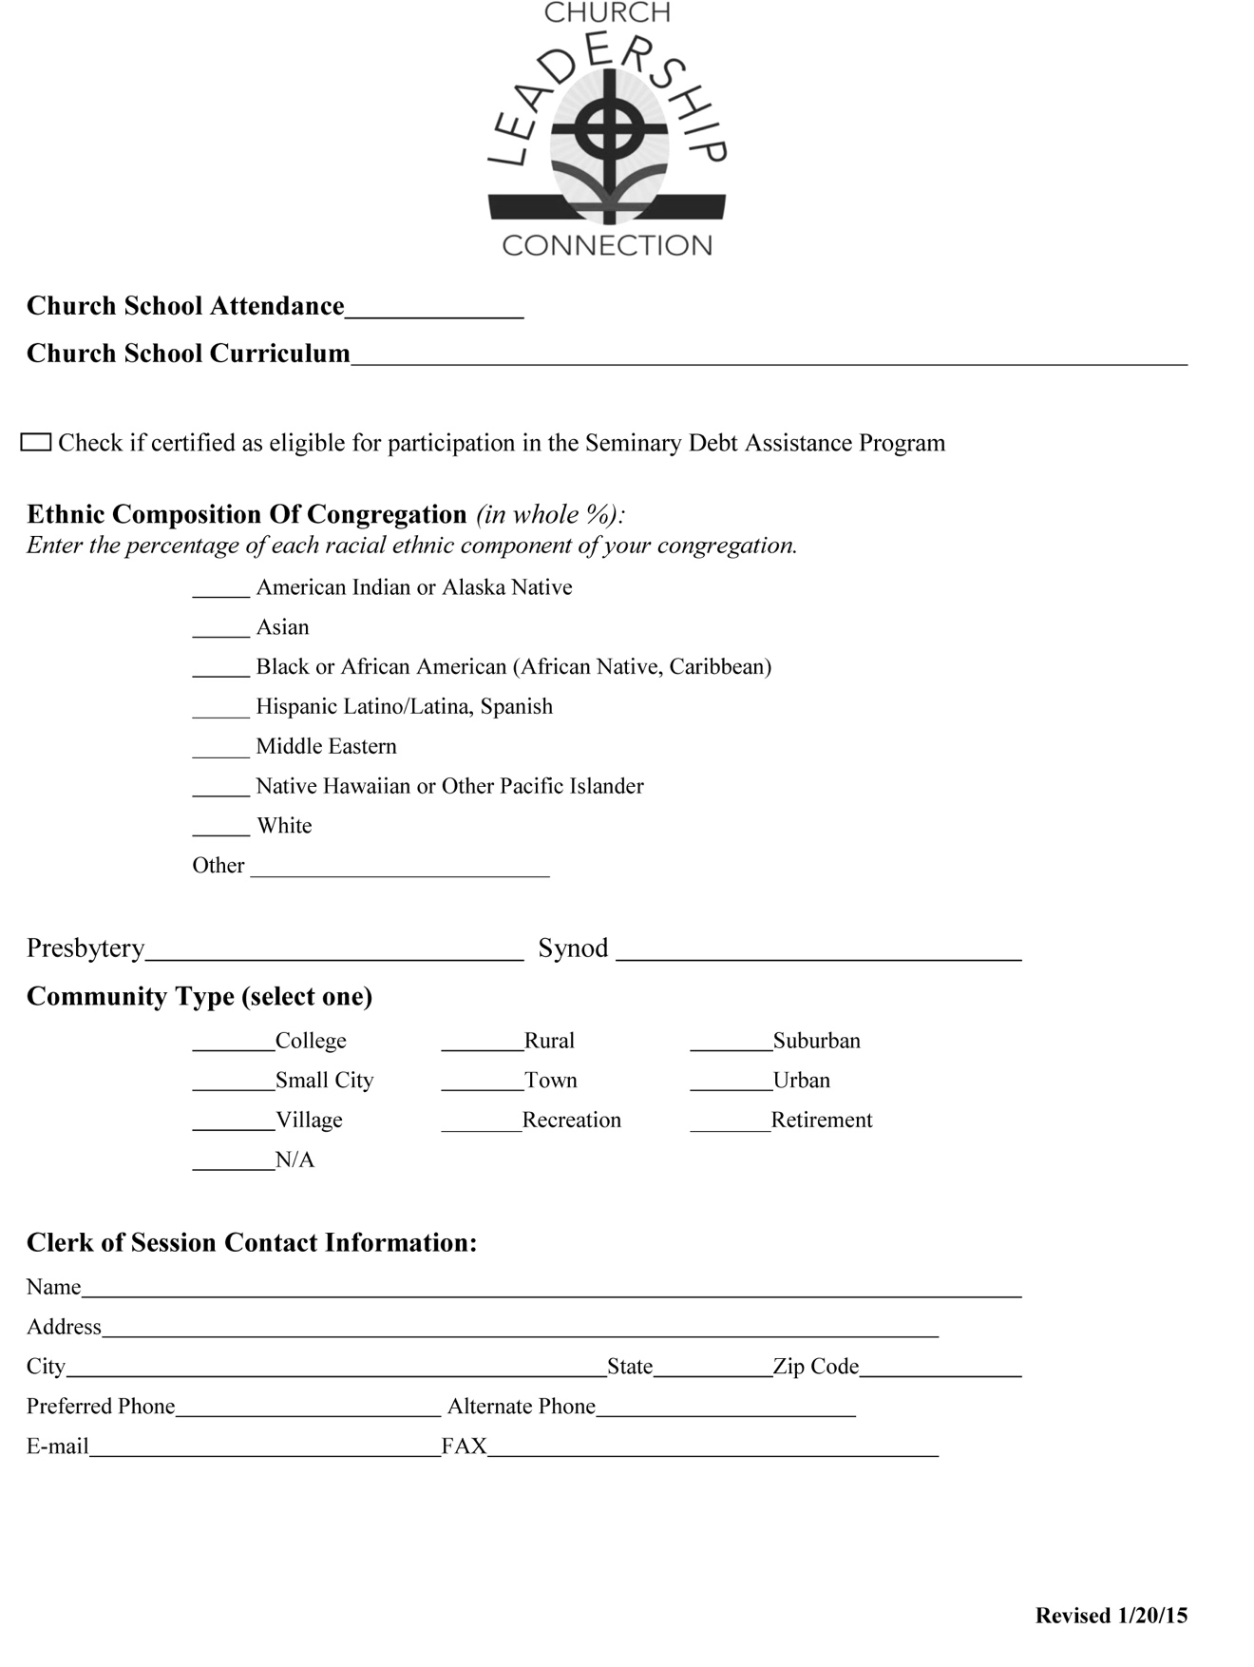

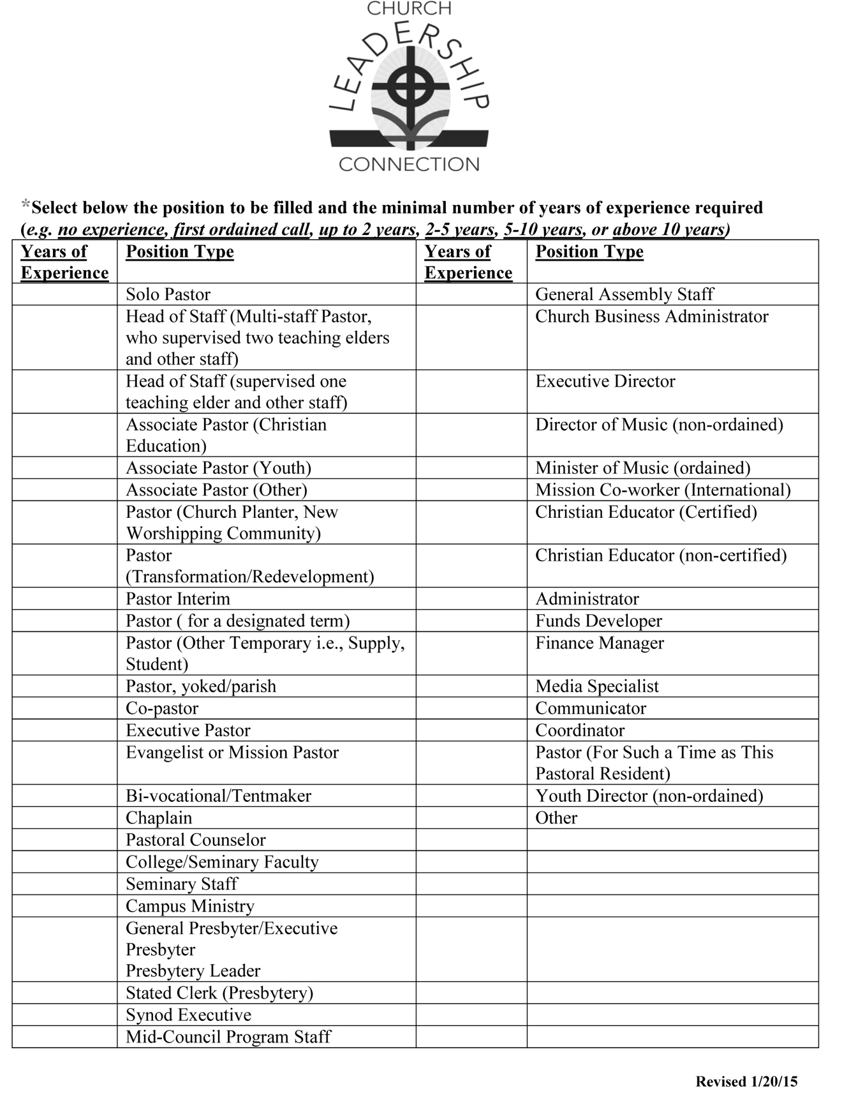

If your church has fewer than 150 members and a budget of less

than $250,000 contact your COM to participate in the program. For more information see

<http://www.pensions.org/plansandprograms/assistanceprogram/pages/pastors-vocational-leadershipneeds.aspx>.

Your presbytery is **Flint River**

Your synod is **South Atlantic**

For smaller congregations. Check this website: <http://www.presbyterianmission.org/ministries/residency/>

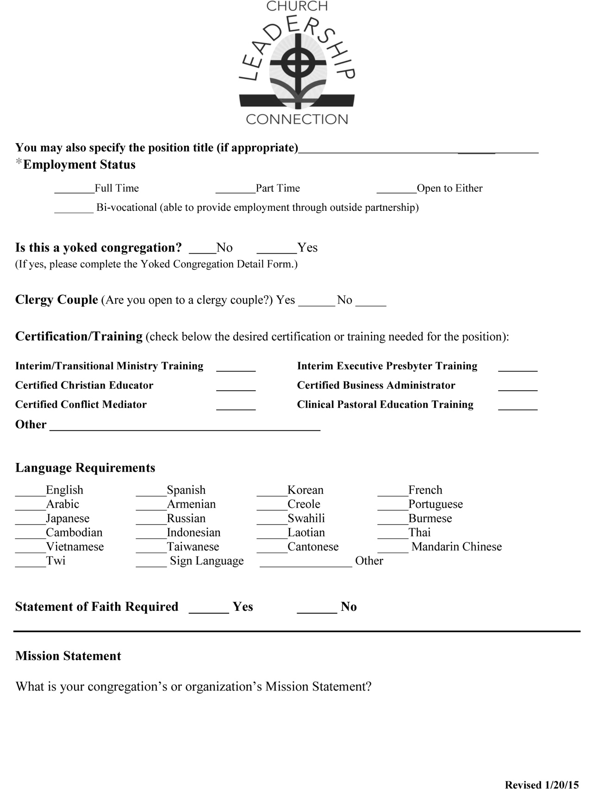

Choose only one category, and indicate the experience level you are seeking.

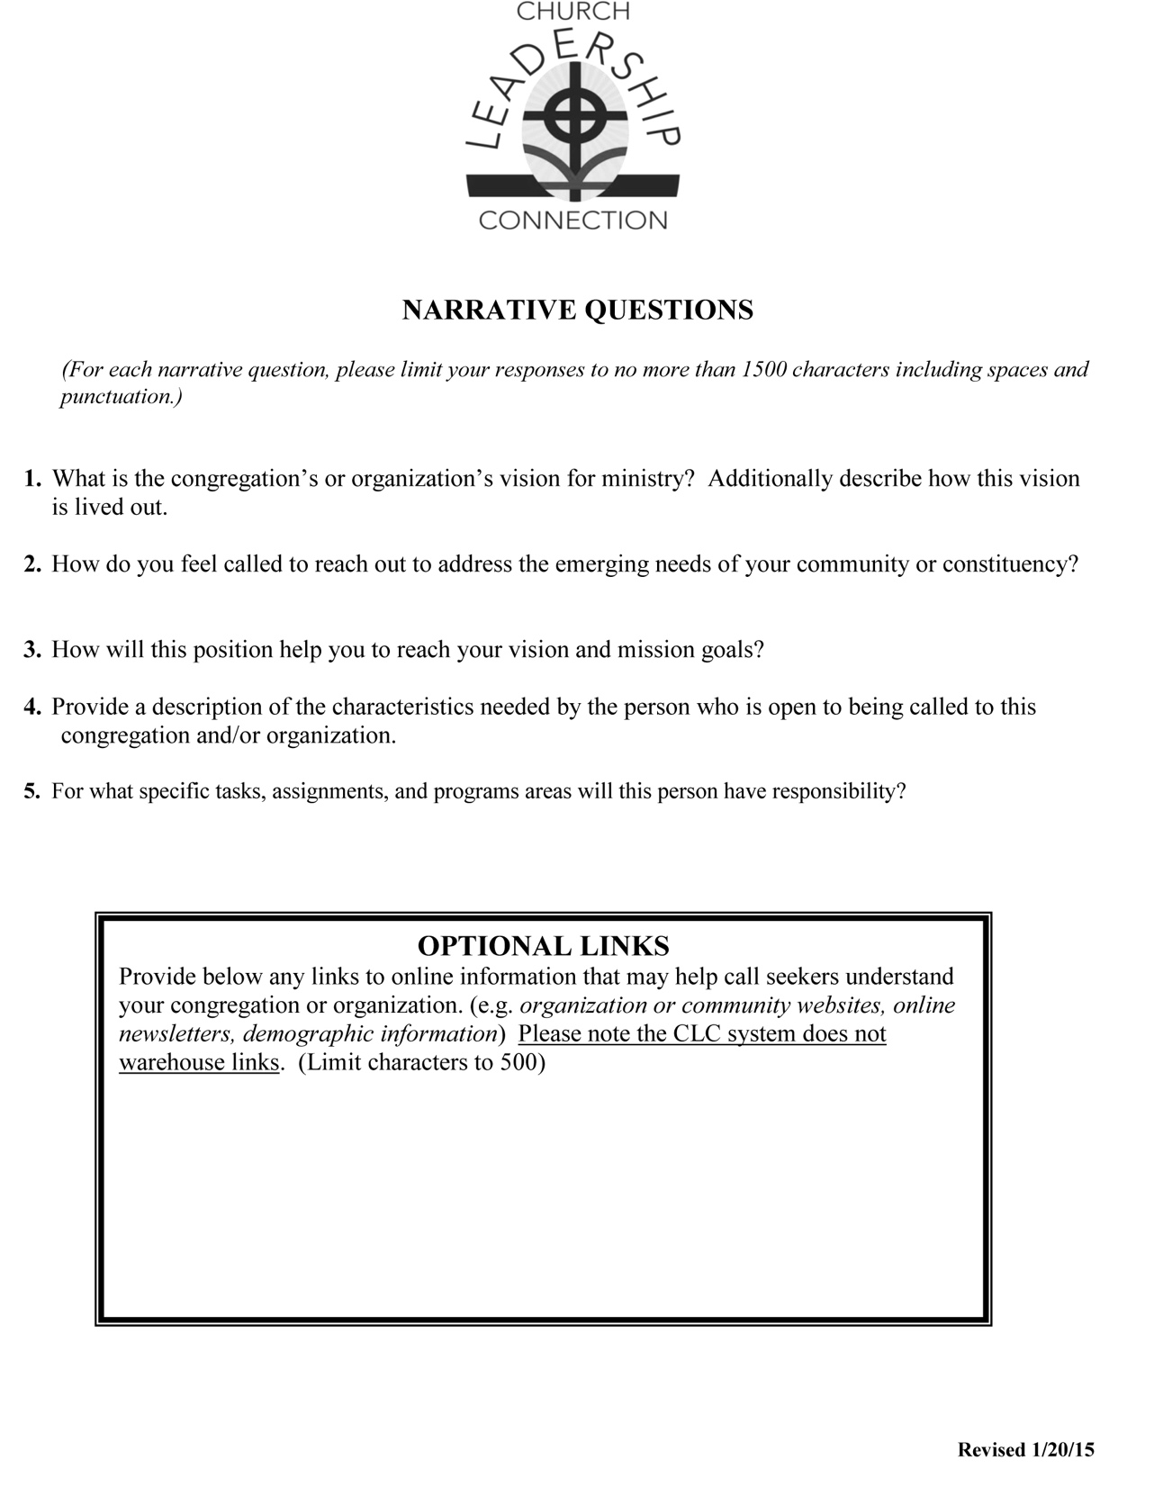

Think carefully about this… some training may be helpful to ask for… for instance, Clinical Pastoral Education might be helpful for someone who will be doing a lot of pastoral care.

This is one place where you can share any particular theological issues that deeply inform or shape your ministry, such as listing membership in various affinity groups, etc.

A yoked congregation is two or more congregations seeking one pastor to share

Most PNCs require a Statement of Faith because it helps them to determine if the candidate’s theological position is compatible with the congregation’s.

This is a good place to identify any particular focus for Associate Pastors (Discipleship, Youth, etc.)

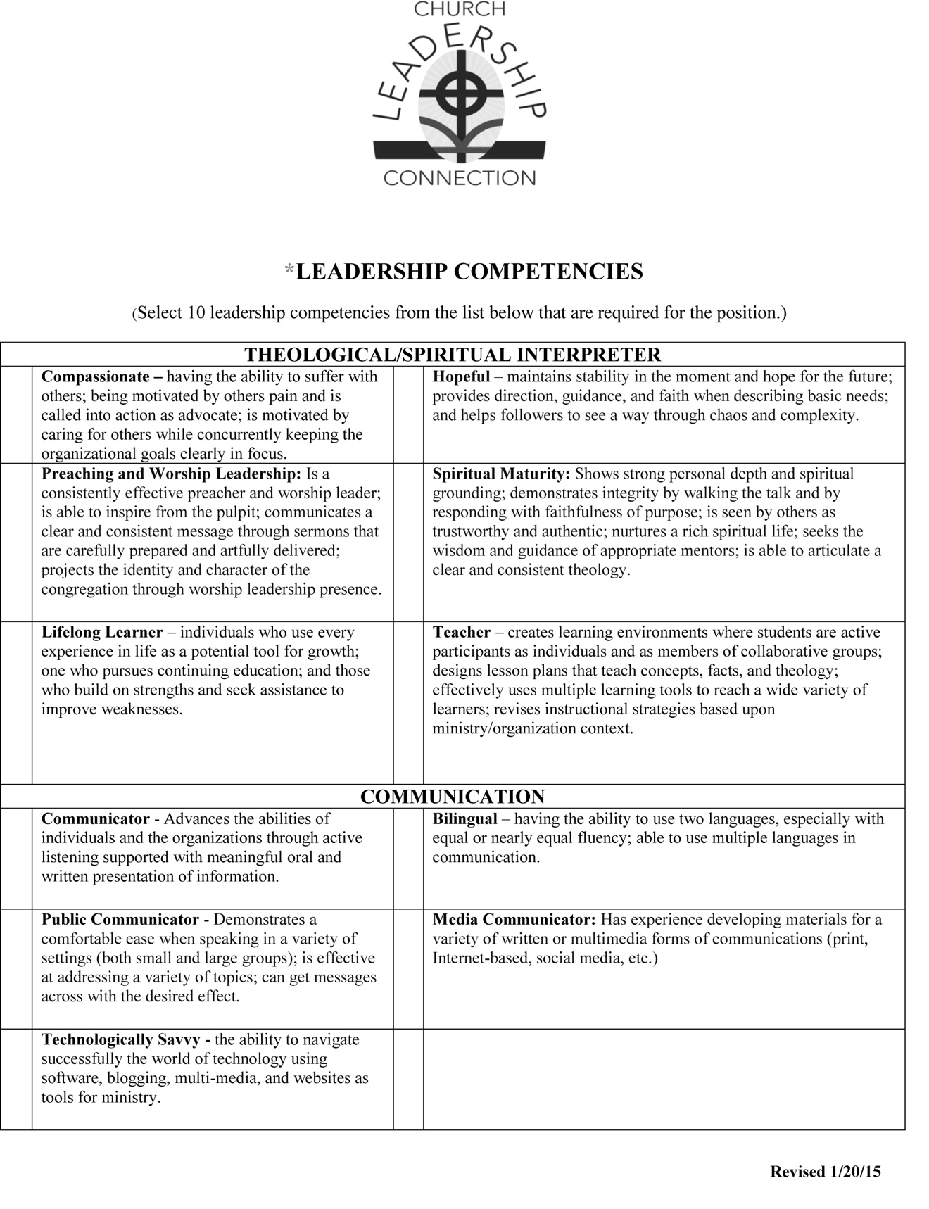

This is where you outline the job duties, including your expectations of the pastor’s participation in the larger church and/or ecumenical or civic communities, boards of directors, etc.

This where you give a person description (sense of humor, strong leader, calm presence, etc.) of the candidate you seek.

In describing how the vision is lived out, you might want to include descriptions of staff and special teams as well as particular ministry/mission activities. This is also the place where you can make note of any theological issues that give shape to your ministry.

NOTE: 1500 characters!

A great way to give more information than the 1500 characters will allow and another good reason to have your website up to date.

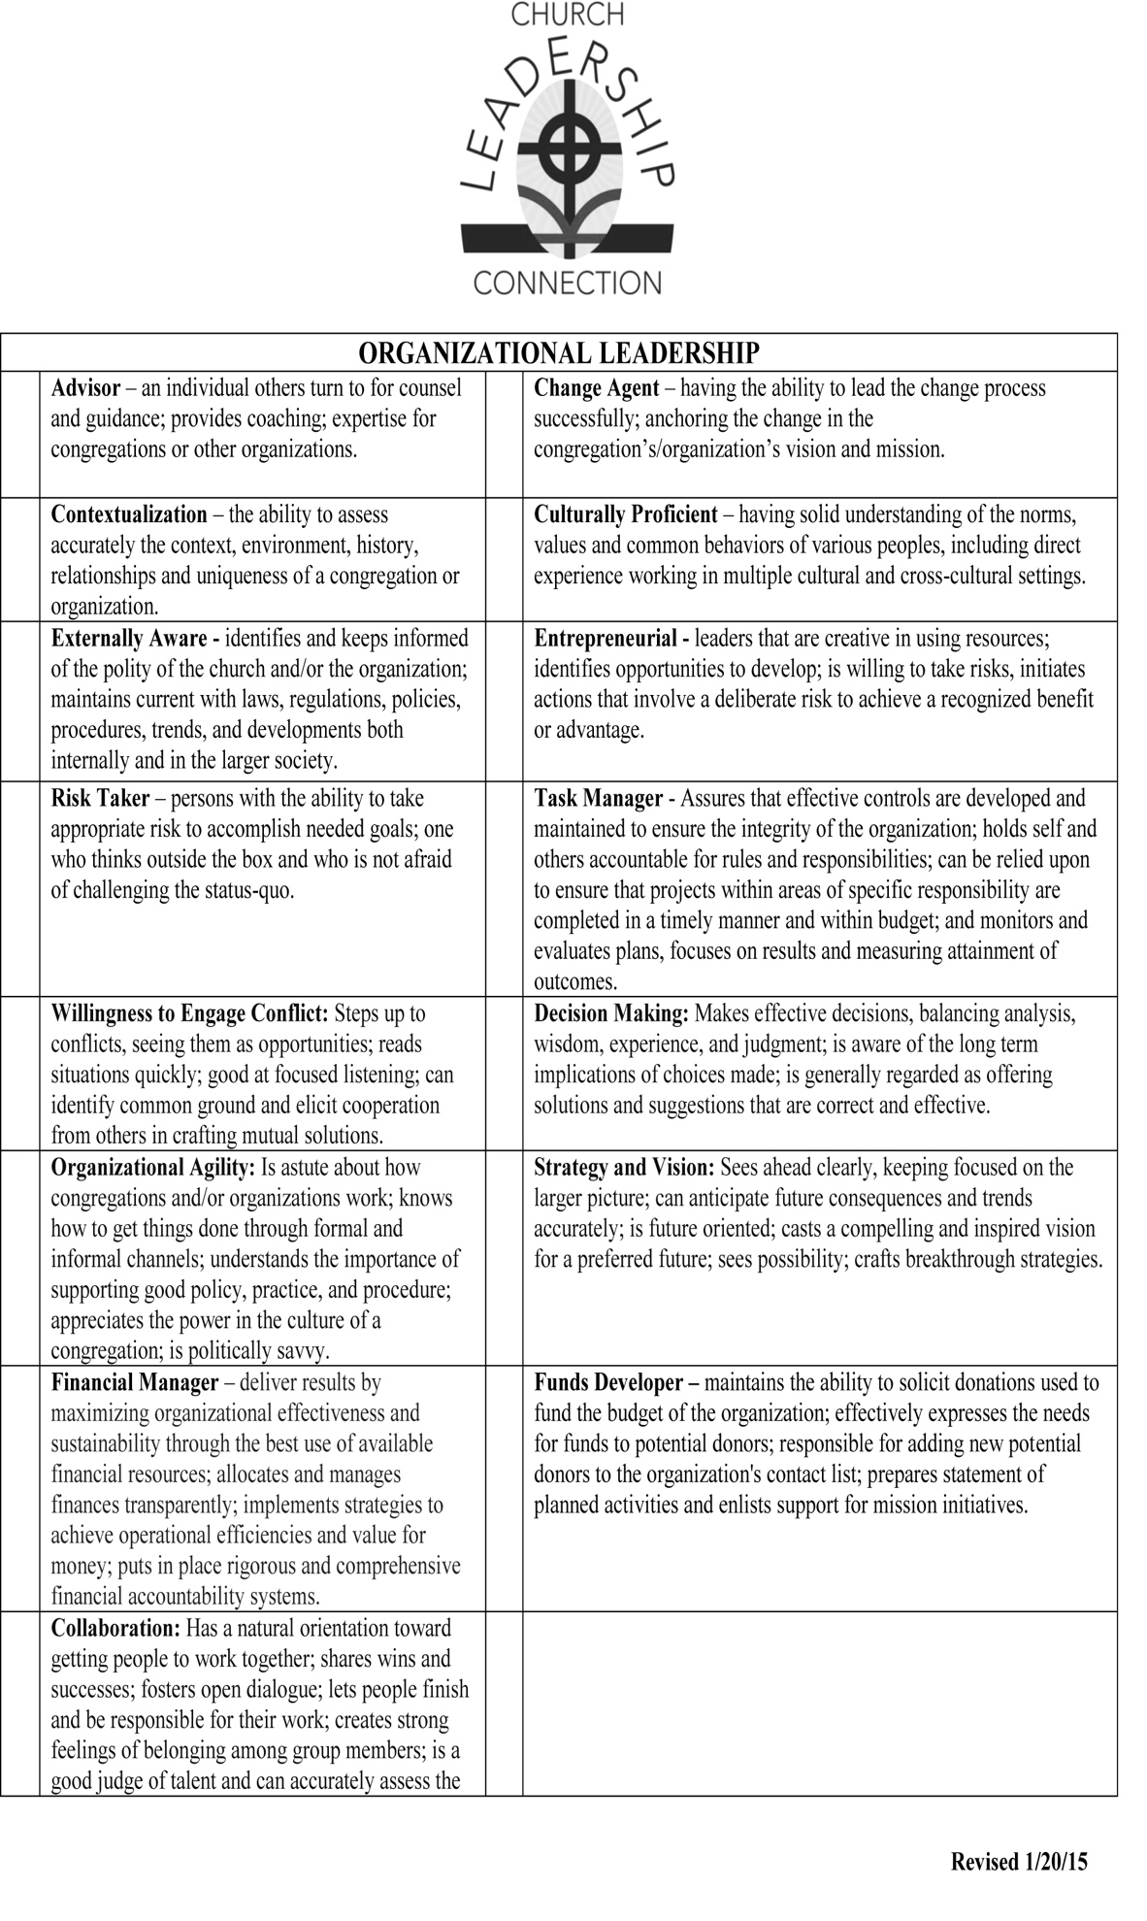

Please be aware that these will print out alphabetically by category rather than in terms of your priority, BUT you should be clear as a PNC which things are most important before you begin interviews.

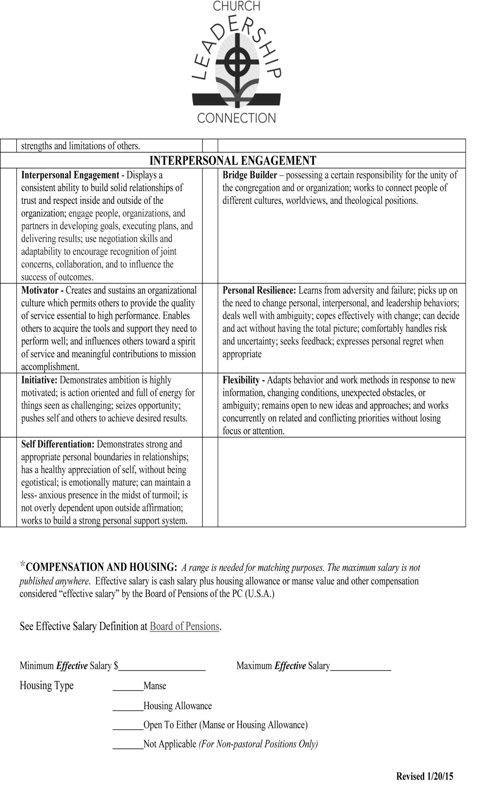

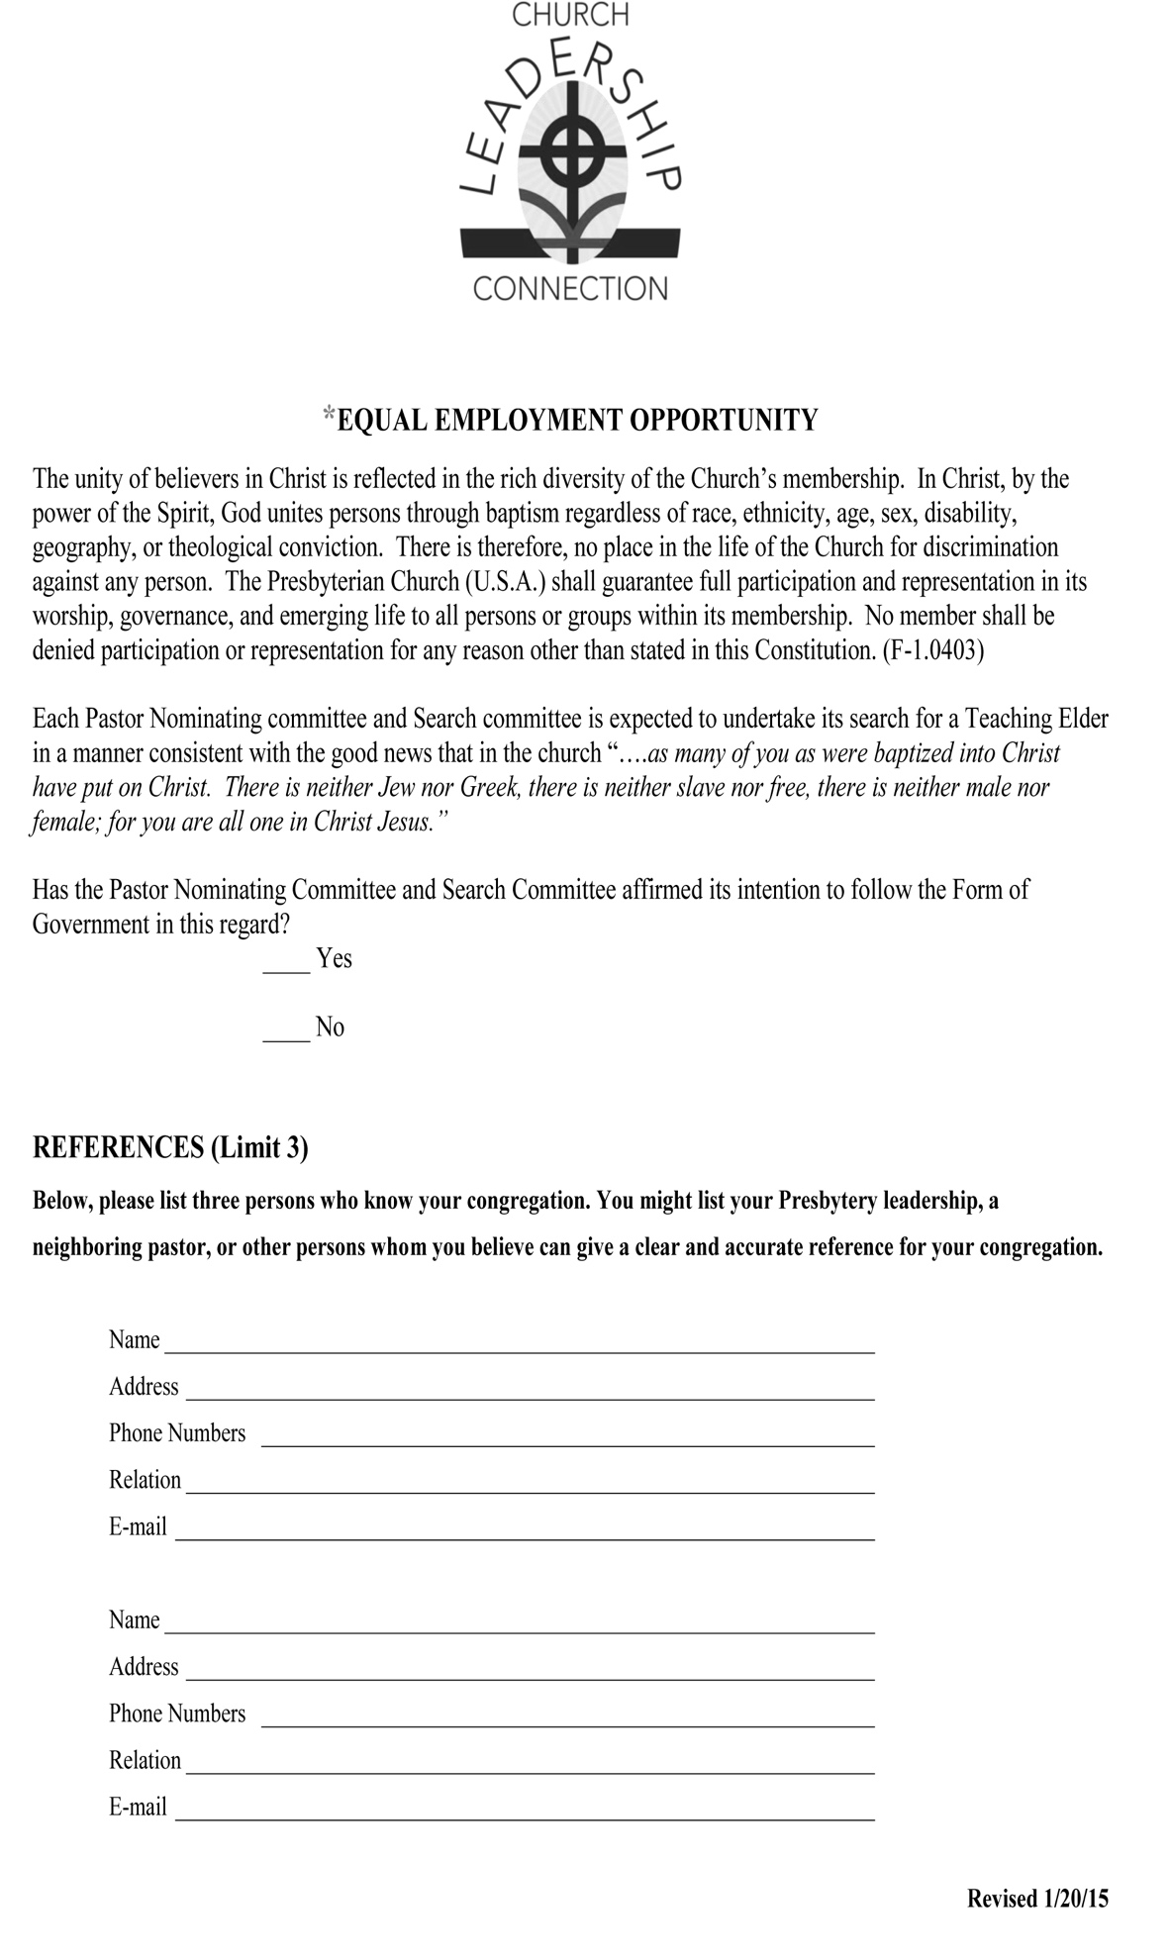

NOTE: The maximum is not visible to candidates.

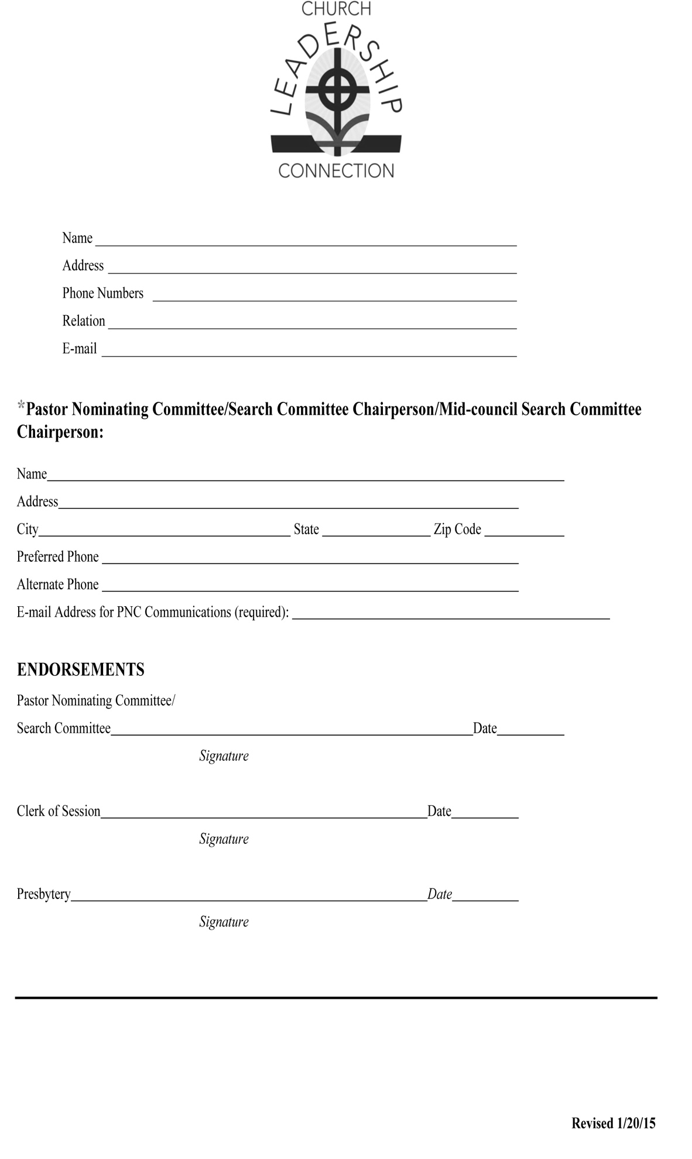

Do NOT list current members of the congregation here. Confidentiality is important! Your COM liaison, presbytery staff, and/or a recent member who has moved away from the area can serve as thoughtful references.